metin, noel ağacı, noel içeren bir resim

Açıklama otomatik olarak oluşturuldu

**EEE-3003 - Electromechanical Energy Conversion**

**DESIGN PROJECT**

SINGLE PHASE TRANSFORMER CALCULATOR

**Group Members**

Ahmad Zameer NAZARI

*220702706*

İsmet Mert ŞEN

*210702011*

**Name of Lecturers**

Prof. Dr. Sırrı Sunay Gürleyük

Arş. Gör. Ali Can Erüst

Single Phase Transformer

Calculator GUI

# Table of Contents

Design Problem 4

Abstract 4

Situation / Problem 4

Solution 4

Design GUI 5

Application Overview 5

Impedances and Equivalent Circuits 6

Voltage Regulation and Plot 7

Efficiency, Power Losses and Plot 8

Links 9

Link to Video presenting the GUI 9

Link to Source Code 9

# Design Problem

## Abstract

In a transformer, its excitation branch components, series impedances, and in addition various losses, voltage regulation and efficiency are quite essential quantities that taken together can fully describe a transformer.

All these quantities can be determined from a small set of initial data about the transformer and a few experimental tests, namely, the open- and short-circuit tests.

## Situation / Problem

Suppose we have before us a $15\text{kVA}$, $2300/230\text{V}$ transformer, and its open and short circuit test results are:

|  |  |
| --- | --- |
| **Open Circuit Test** | **Short Circuit Test** |
| $$V_{oc}=230\text{V}$$ | $$V_{sc}=47\text{V}$$ |
| $$I_{oc}=2.1\text{A}$$ | $$I_{sc}=6.0\text{A}$$ |
| $$P_{oc}=50\text{W}$$ | $$P_{sc}=160\text{W}$$ |

## Solution

*Submitted earlier on DYS, and as such is not copied here.*

# Design GUI

## Application Overview

The GUI developed to provide quick solutions to problems such as these, was the aim of our group. The Single-Phase Transformer Calculator, as its name suggests, is aimed at single phase transformers.

With a few initial quantities provided, such as those in the aforementioned problem, namely transformer power ratings and open- and short-circuit test results, can output a whole range of transformer characteristics.

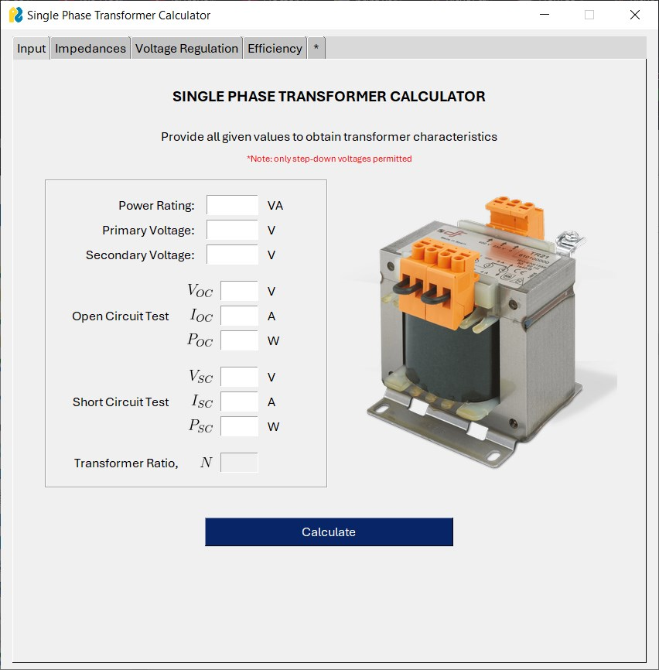

For the sake of simplicity of code, it provides accurate results only for step-down transformers. Step-up transformers are not permitted.

For our given problem, the output of the transformer calculator application are as follows:

## Impedances and Equivalent Circuits

All the equivalent impedances and corresponding components are determined. They are provided in context of which side they have been referred to.

Notice that since it is a step-down transformer, and impedances transform with square of turns ratio, the impedances referred to secondary are smaller than their values in primary.

Note: Admittance unit has been mistakenly input as $Ω$ instead of $\text{S}$, in the code, and has since been corrected.

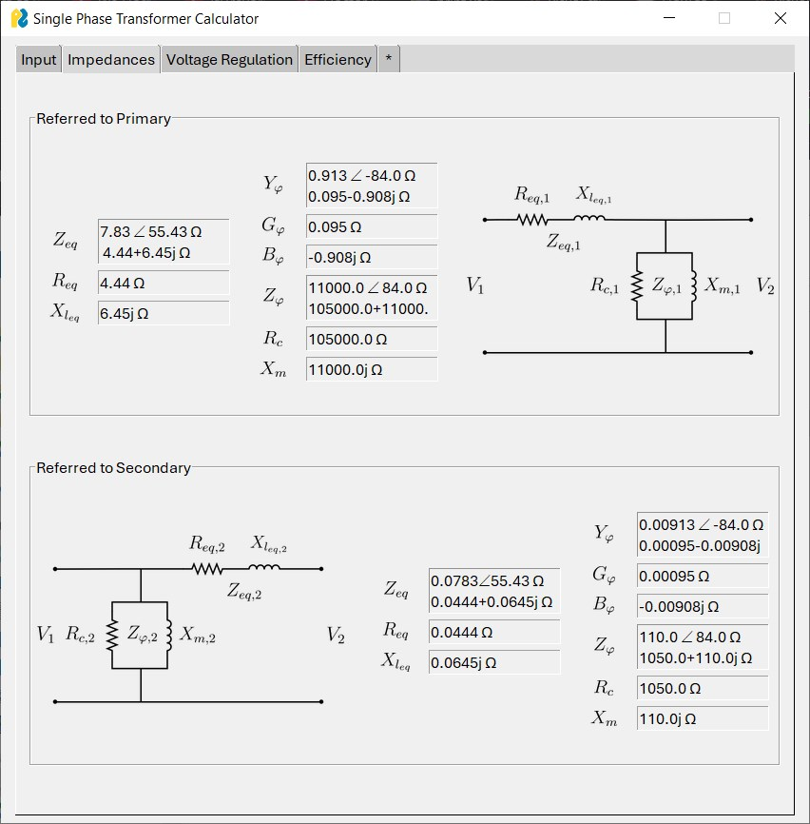

## Voltage Regulation and Plot

Voltage Regulation is also calculated at an arbitrary 0.8 lagging and 0.8 leading power factor.

A plot is also provided of the three VR values for comparison.

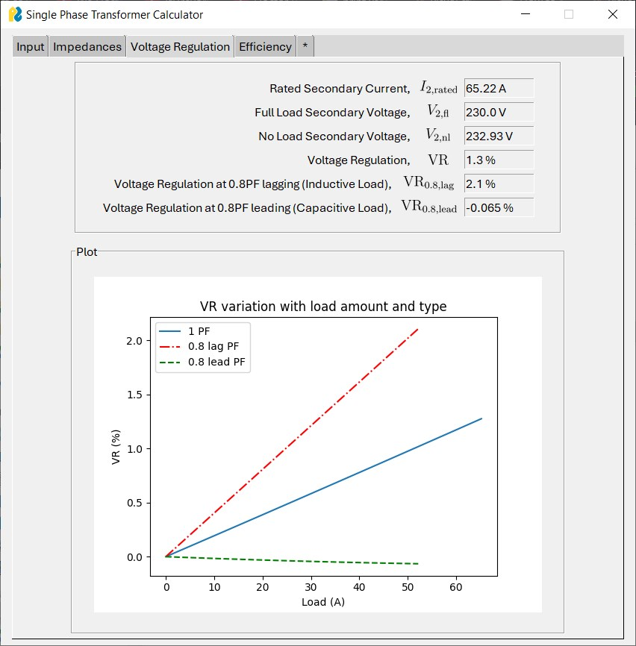

## Efficiency, Power Losses and Plot

The division of input power to the useful output power, and the different types of losses, such as Copper Loss and Core Loss (that include eddy current losses and hysteresis losses) are calculated. Subsequently transformer efficiency can be computed.

A graph is plotted of the variation of efficiency with increasing load (which corresponds with increasing load current). A comparison can be made with the graphs of losses on the right y-axis.

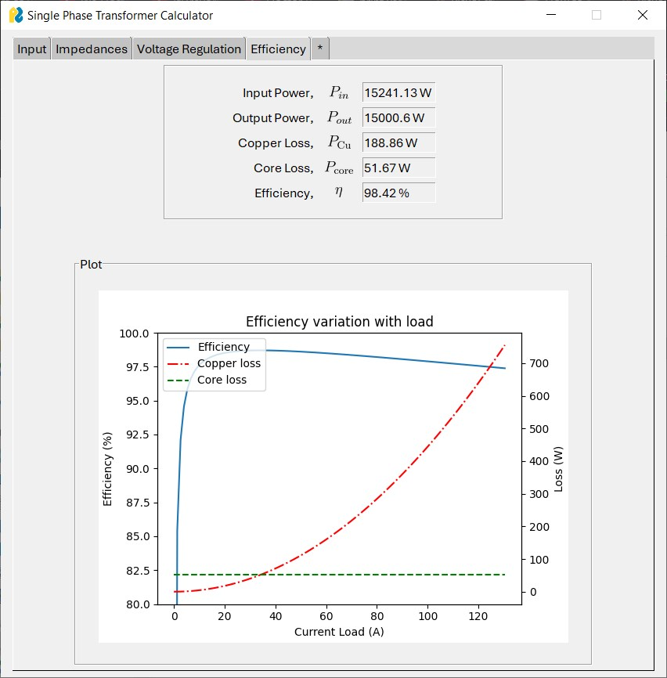

# Links

## Link to Video presenting the GUI

<https://youtu.be/XEFpZwII7mk>

## Link to Source Code

<https://github.com/az-yugen/EEE-3003-EM-Energy-Conversion-LAB>

